**OUTPUT:**

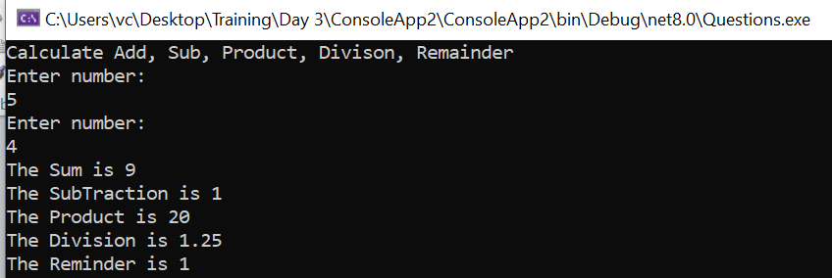

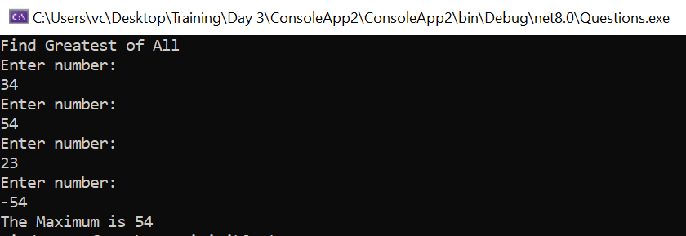

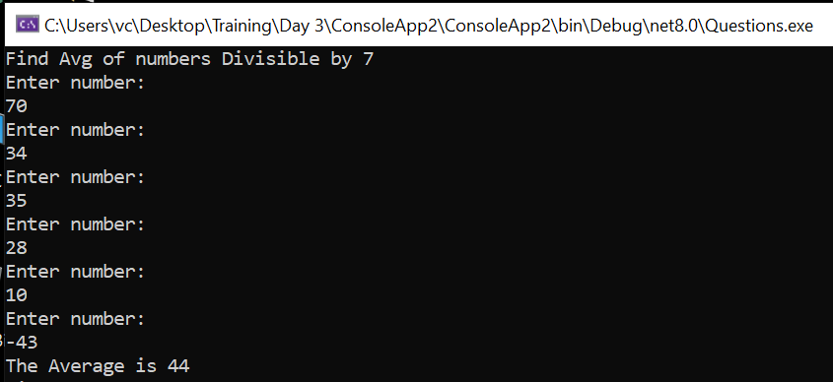

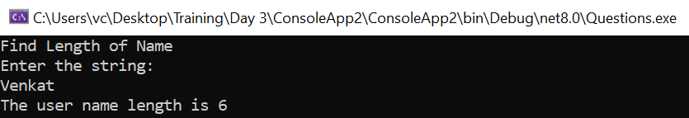

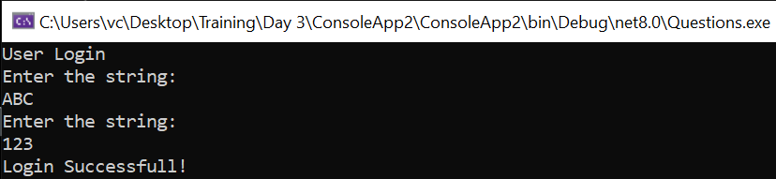

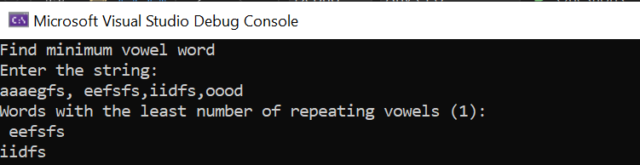

**CODE:**

using Microsoft.VisualBasic;

using static System.Net.Mime.MediaTypeNames;

namespace ConsoleApp2

{

internal static class Program

{

static int Add(int num1, int num2)

{

return num1 + num2;

}

static int Sub(int num1, int num2)

{

return num1 - num2;

}

static int Product(int num1, int num2)

{

return num1 * num2;

}

static int Remainder(int num1, int num2)

{

return num1 % num2;

}

static bool Divide(int num1, int num2, out string msg, out double res, out int rem)

{

msg = "";

res = 0;

rem = 0;

if(num2 == 0)

{

msg = "Cannot divide by 0";

return false;

}

res = (double)num1 / (double)num2;

rem = Remainder(num1, num2);

return true;

}

static int TakeNumber()

{

int num1;

Console.WriteLine("Enter number:");

while (!int.TryParse(Console.ReadLine(), out num1))

Console.WriteLine("Invalid entry. Enter valid number");

return num1;

}

static string TakeString()

{

string inp;

Console.WriteLine("Enter the string:");

inp = Console.ReadLine()??"";

return inp;

}

static void Calculate()

{

int num1, num2;

num1 = TakeNumber();

num2 = TakeNumber();

PrintResult(Convert.ToString(Add(num1, num2)), "Sum");

PrintResult(Convert.ToString(Sub(num1, num2)), "SubTraction");

PrintResult(Convert.ToString(Product(num1, num2)), "Product");

bool val = Divide(num1, num2, out string msg, out double result, out int reminder);

if(val){

PrintResult(Convert.ToString(result), "Division");

PrintResult(Convert.ToString(reminder), "Reminder");

}

else

{

Console.WriteLine(msg);

}

}

static void PrintResult(string sum, string ops)

{

Console.WriteLine($"The {ops} is {sum}");

}

static void FindGreatest()

{

int num1;

int maximum = int.MinValue;

while (true)

{

num1 = TakeNumber();

if (num1 < 0)

{

break;

}

if (num1 > maximum)

{

maximum = num1;

}

}

PrintResult(Convert.ToString(maximum), "Maximum");

}

static void FindAvgBy7()

{

int num1;

int c = 0, sum1=0;

while (true)

{

num1 = TakeNumber();

if (num1 < 0)

{

break;

}

if (Remainder(num1, 7) == 0 && num1 !=0)

{

sum1 += num1;

c++;

}

}

PrintResult(Convert.ToString((double)(sum1/c)), "Average");

}

static void StringLength()

{

string Name = TakeString();

PrintResult(Convert.ToString(Name.Length), "user name length");

}

static void UserLogin()

{

int counts = 0;

while(true)

{

if (counts > 2)

{

Console.WriteLine("The number of attempts exceeded.");

break;

}

string username = TakeString();

string password = TakeString();

if(username=="ABC" && password == "123")

{

Console.WriteLine("Login Successfull!");

break;

}

else

{

Console.WriteLine("Invalid Username or Password");

counts++;

Console.WriteLine($"Attempt {counts}\n");

}

}

}

static int CountRepeatingVowels(string word)

{

word = word.ToLower();

char[] vowels = ['a', 'e', 'i', 'o', 'u'];

int count = 0;

for (int i = 0; i < word.Length - 1; i++)

{

if (vowels.Contains(word[i]) && vowels.Contains(word[i + 1]))

{

count++;

i++;

}

}

return count;

}

static void VowelWord()

{

string line = TakeString();

string[] words = line.Split(',');

int minVowelCount = int.MaxValue;

string[] minVowelWords = [];

foreach (string word in words)

{

int vowelCount = CountRepeatingVowels(word);

if (vowelCount < minVowelCount)

{

minVowelCount = vowelCount;

minVowelWords = [word];

}

else if (vowelCount == minVowelCount)

{

minVowelWords = minVowelWords.Append(word).ToArray();

}

}

Console.WriteLine($"Words with the least number of repeating vowels ({minVowelCount}):");

foreach (string word in minVowelWords)

{

Console.WriteLine(word);

}

}

static void Main(string[] args)

{

//sum, sub, product, division, remainder

Console.WriteLine("Calculate Add, Sub, Product, Divison, Remainder");

Calculate();

// Finding Greatest number

Console.WriteLine("Find Greatest of All");

FindGreatest();

//Find Avg of numbers Divisible by 7

Console.WriteLine("Find Avg of numbers Divisible by 7");

FindAvgBy7();

//Length of Name

Console.WriteLine("Find Length of Name");

StringLength();

//User Login

Console.WriteLine("User Login");

UserLogin();

//Find minimum Vowel words.

Console.WriteLine("Find minimum vowel word");

VowelWord();

}

}

}